Output images for 4th:
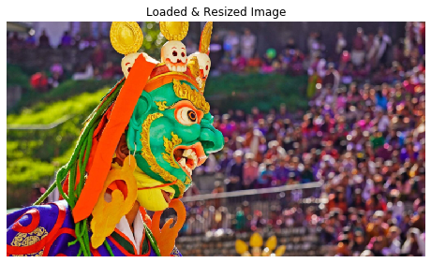
For size 5: sigma=0.833, kernel size=7
For size 20: sigma=3.333, kernel size=21
Saving output images...
Saved: results_no_cv2\box_5_unnormalized.png
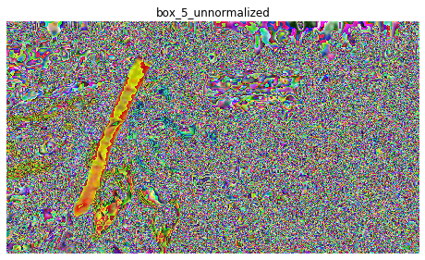
Saved: results_no_cv2\box_5_normalized.png
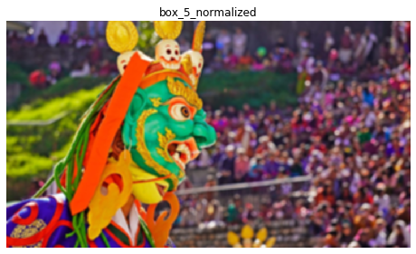
Saved: results_no_cv2\box_20_unnormalized.png
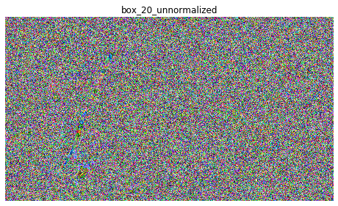

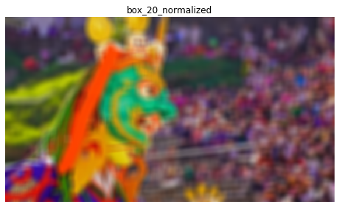
Saved: results_no_cv2\gaussian_5_normalized.png
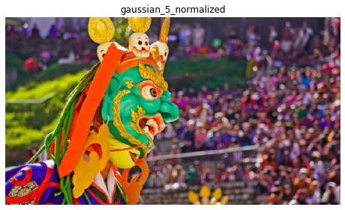
Saved: results_no_cv2\gaussian_5_unnormalized.png
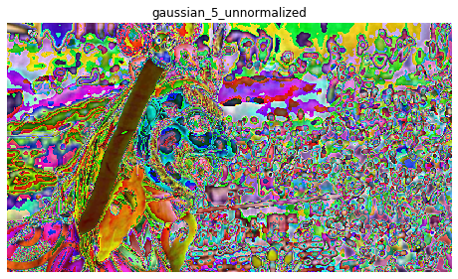
Saved: results_no_cv2\gaussian_20_normalized.png
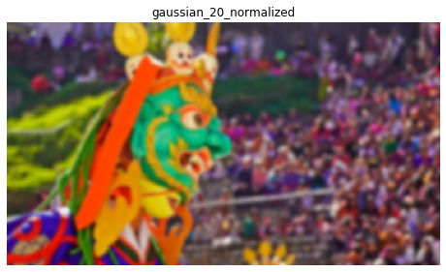
Saved: results_no_cv2\gaussian_20_unnormalized.png
